Detail Design Document
For Android Audio Processing on Raspberry Pi.

Votary Softech Solutions Pvt. Ltd.
Plot No: 76, Lumbini layout,
Near Euro school,
Gachibowli-I (V), Hyderabad,
Telangana - 500032,
India.

Revision History

Version (x.y) | Date of Revision | Description of Change | Reason for Change | Affected Sections | Approved By
0.1 |  | New Definition | New | ALL

Approval History

Version (x.y) | Prepared By | Reviewed By/Date | Approved By/Date

- Contents
1 Define 4
1.1 Overview 4
1.2 Assumptions 4
1.3 Limitations 4
1.4 Glossary 4
2 Specify 4
2.1 Scope 4
2.2 Design Approach 5
2.3 Alternative Design Approaches Considered 5
2.4 Module Design 5
2.4.1 Module Name and Description 5
2.5 External Interfaces 6
2.6 Design Tools 6
3 Architecture 6
3.1 Block Diagrams 6
3.2 Activity Steps 8
3.2.1 Continuous Integration……………………………………………….9
3.3 Deployment diagrams
3.4 State Transition Diagram (Optional)
3.5 State Transition Table
4 Design
4.1 Class Diagrams
4.2 Sequence Diagrams
4.3 Database Design
4.4 Wireframes
5 Implementation
5.1 Directory Structure
5.2 Libraries and Framework
5.3 Error Handling
5.4 Status Codes and Description
6 Validate
7 Deploy
8 Maintain

1. DEFINE

1.1 Overview
The aim of the project is to process the audio input on android and perform different alterations (like noise cancellation) and produce the desired ouput.

1.2 Assumptions

- Should have knowledge on Kernel Configuration.
- Have knowledge on Cross-Compilation tool chains.
- Full specifications of the Raspberry Pi 3 B.
- Should have knowledge on Gstreamer Framework.
- Have knowledge Raspberry PI configurations.

2 SPECIFY

2.1 Phase I(Linux) :
In the Phase-I we need to process the audio on android where the source (.mp3) files are present on the Local system(Linux PC) using Gstreamer.

2.2 Phase-II(Raspberry pi) :

1.Stream the audio (mp3,wav,ogg) files which are present on the Raspberry Pi using GStreamer.
2.Stream the video (mp4,mpeg) files which are present on the Raspberry Pi using Gstreamer.
3.Capture the still image from the PI camera module which is connected to the Raspberry Pi using CSI Interface.

2.3 Phase-III(Pi3 Android) :

1. capturing still pictures on Android raspberry pi3

3 ARCHITECTURE :
3.1 Block Diagram :
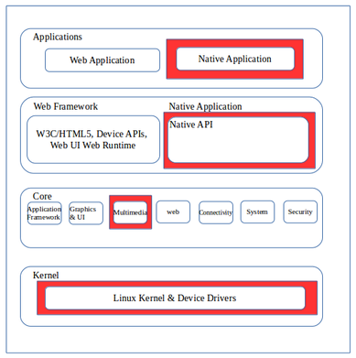

4.DESIGN
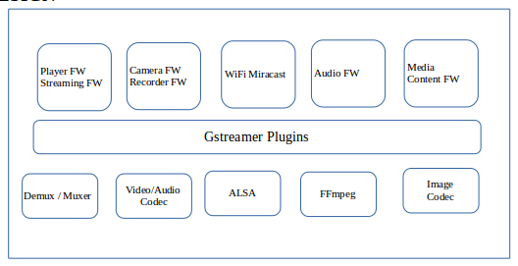
5.IMPLEMENTATION
Gstreamer Installation Procedure:
You need to edit the sources.list file so enter:
sudo nano /etc/apt/sources.list
and add the following to the end of the file:
deb http://vontaene.de/raspbian-updates/ . Main
Press CTRL+X to save and exit
Now run an update (which will make use of the line just added):
sudo apt-get update
Now install gstreamer
sudo apt-get install gstreamer1.0
5.1 Phase I :
Audio and Video Streaming on Linux PC:
1. To Stream Local audio (mp3, wav) on Linux PC use the below command
gst-play-1.0 /...path to file .../test.mp3
2. To Stream Local video (mp4) on Linux PC use the below command
gst-play-1.0 /...path to file.../test.mp4
5.2 Phase II :
Audio and Video Streaming on Raspberry PI3:
1. To Stream Local audio (mp3, wav) on Raspberry Pi3 use the below command
gst-play-1.0 /...path to file .../test.mp3
2. To Stream Local video (mp4) on Raspberry pi3 use the below command
gst-play-1.0 /...path to file.../test.mp4

Pi Camera Configuration:
To obtain the Raspberry Pi's configuration tool, open a Terminal window and type the following Linux command
sudo raspi-config
After typing the configuration tool command and hitting the enter key, a new window will appear on the monitor's screen as shown next. Using the down arrow on your keyboard, select the "Enable Camera" option:
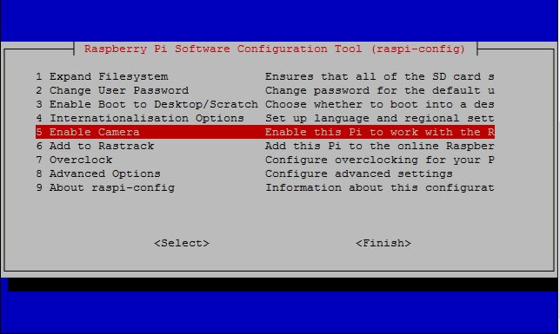
With the selection made, the configuration tool will ask if you want the option to enable:
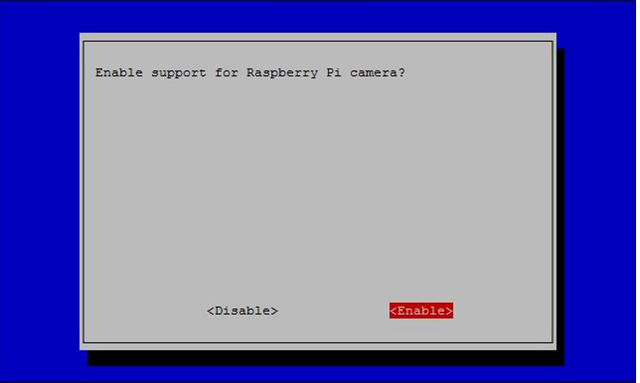

The final step in saving the camera feature is to reboot the Raspberry Pi:
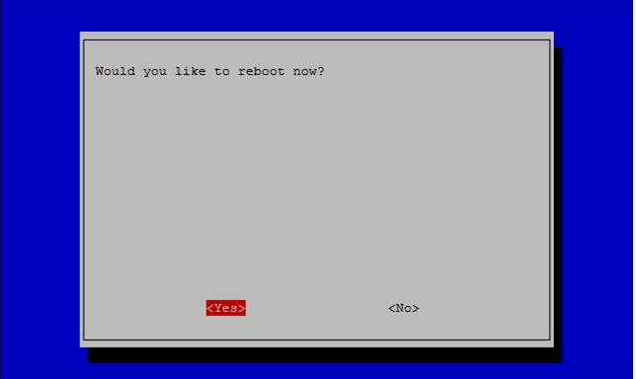
Your Raspberry Pi camera feature is ready. Congratulations! You can now build your Pi Camera.

Still captures
To capture the still image on Raspberry Pi use the below command
Take a default capture after 2s (times are specified in milliseconds) on the viewfinder, saving in image.jpg:
raspistill -t 2000 -o image.jpg
Take a capture at a different resolution:
raspistill -t 2000 -o image.jpg -w 640 -h 480
Reduce the quality considerably to reduce file size:
raspistill -t 2000 -o image.jpg -q 5

5.3 Phase III :

1. Port the Android OS into the Raspberry PI
2. Capture the still image on the Raspberry PI using the PI camera module

ISSUES :
1. Video frames are looping within two frame buffers.

